Executive Summary
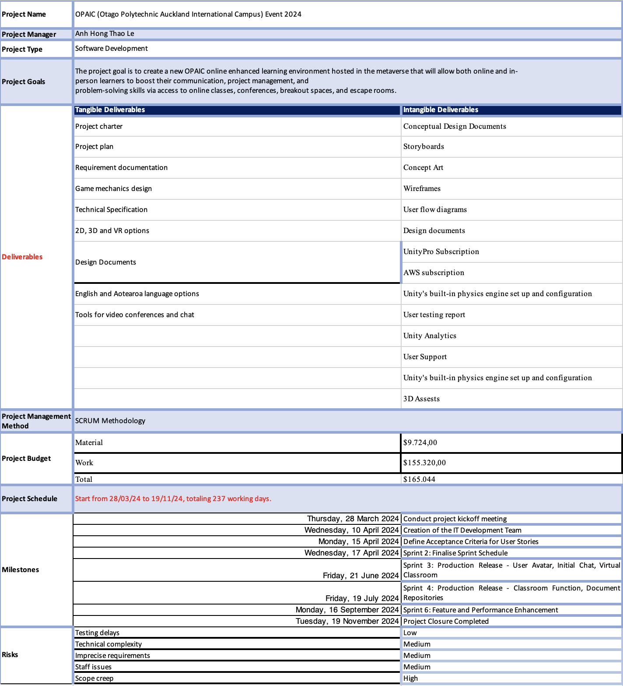

Background and Purpose

OPAIC prides itself on offering quality, career-focused education to its diverse student body, which is exclusively comprised of international learners from around the world. It is renowned for bringing out motivated, employable graduates who are in high demand everywhere, so OPAIC strives to give students real-world skills that will lead to prosperous professions. By incorporating immersive game simulations into construction courses, OPAIC aims to improve the learning environment by equipping students with industry-relevant skills and practical knowledge to help them meet the ever-changing demands of the construction industry. This innovative method improves the quality of education overall and fits with the institution's commitment to sustainability and flexibility in the face of a constantly shifting global educational environment.
The purpose of the IT project is to provide students studying construction management with an immersive and experiential learning platform that will improve their comprehension of real-world building settings. With interactive games, students can investigate many facets of construction, such as Construction project budgeting and financial management, including complete life-cycle costing, contract law, contractual risk assessment, and
Organising and managing building projects
Project management, including scheduling, budgeting, quality control, and client satisfaction
Negotiation, people management, and construction business management skills.
The report's first section covers the project scope, including the objectives, deliverables, milestones, requirements, exclusions, and constraints. The next section will explore the methodology, the various assumptions the project must make, and how Māori values will be incorporated into the project's execution and outcome. Lastly, there will be further coverage of project plan elements such as quality controls, project closure, estimations, risk management, project organisation, and communications.

3. Project Scope
A project scope is defined as a precise, measurable description of the project's goal to provide the client or customer with a product or service (Ika, 2009). The project teams and business users must agree on this project's scope (Kumar, 2003). A clearly specified project scope acts as a contract between the project stakeholders and as a guide for the project team. It offers a framework for organising, carrying out, and managing the project, ultimately assisting in its timely and successful completion (Abdilahi et al., 2020). For the end user, precisely specifying deliverables promotes transparency and reduces the possibility of misconceptions by giving them a clear picture of the concrete results they may anticipate (Abdilahi et al., 2020). For project owners and team members, it creates a focus on the project's objectives (Abdilahi et al., 2020). The OPAIC IT project's scope includes creating an extensive online learning environment with realistic simulations, 3D interaction, personalized avatar creation, secure online communication, accessibility for remote learners, top-notch learning standards, sustainable practices, and collaborative learning tools for OPAIC's construction management students.

3.1. Objectives
Project objectives are the outcomes that the project intends to achieve by the point that it is completed (Turner & Turner, 1999). These give a clear picture of the desired results and are the measurable results that a project seeks to attain when it is finished.
The main objective of OPAIC's IT project is to establish an online improved learning environment, especially for construction management students. The platform will provide students with a dynamic and interactive learning environment by including lifelike simulations that involve building a variety of structures, from homes to office buildings. Furthermore, the effort seeks to give students the ability to interact in a three-dimensional format, improving their comprehension of space and practical abilities. Additionally, the simulation game aims to allow students to make customized avatars, encouraging individual learning and a sense of identity. The project prioritizes creating a safe environment for knowledge exchange and skill development by enabling collaborative interactions between students and lecturers inside a protected online platform.

Figure 1 Homepage Mock-up

Figure 2 Sign-in page Mock-up

3.2. Deliverables
A project deliverable is an objective statement of work that is produced by using resources and labour to execute specific tasks within a project within a predetermined time limit (Sokowski, 2015). Malsam (2023) clarified that there are two kinds of deliverables: tangible and intangible deliverables. Intangible deliverables are conceptual and lack a physical shape, whereas tangible deliverables are actual project outcomes having a definite form and substance (Allee, 2008). Allee (2008) further explained that tangible deliverables are physical or concrete outcomes of a project that can be directly observed, measured It is important to remember that, regardless of physical state, both kinds of deliverables still have measurable consequences.
Figure 3 represents the tangible and intangible deliverables of OPAIC IT project’s tangible and intangible deliverables.

Tangible deliverables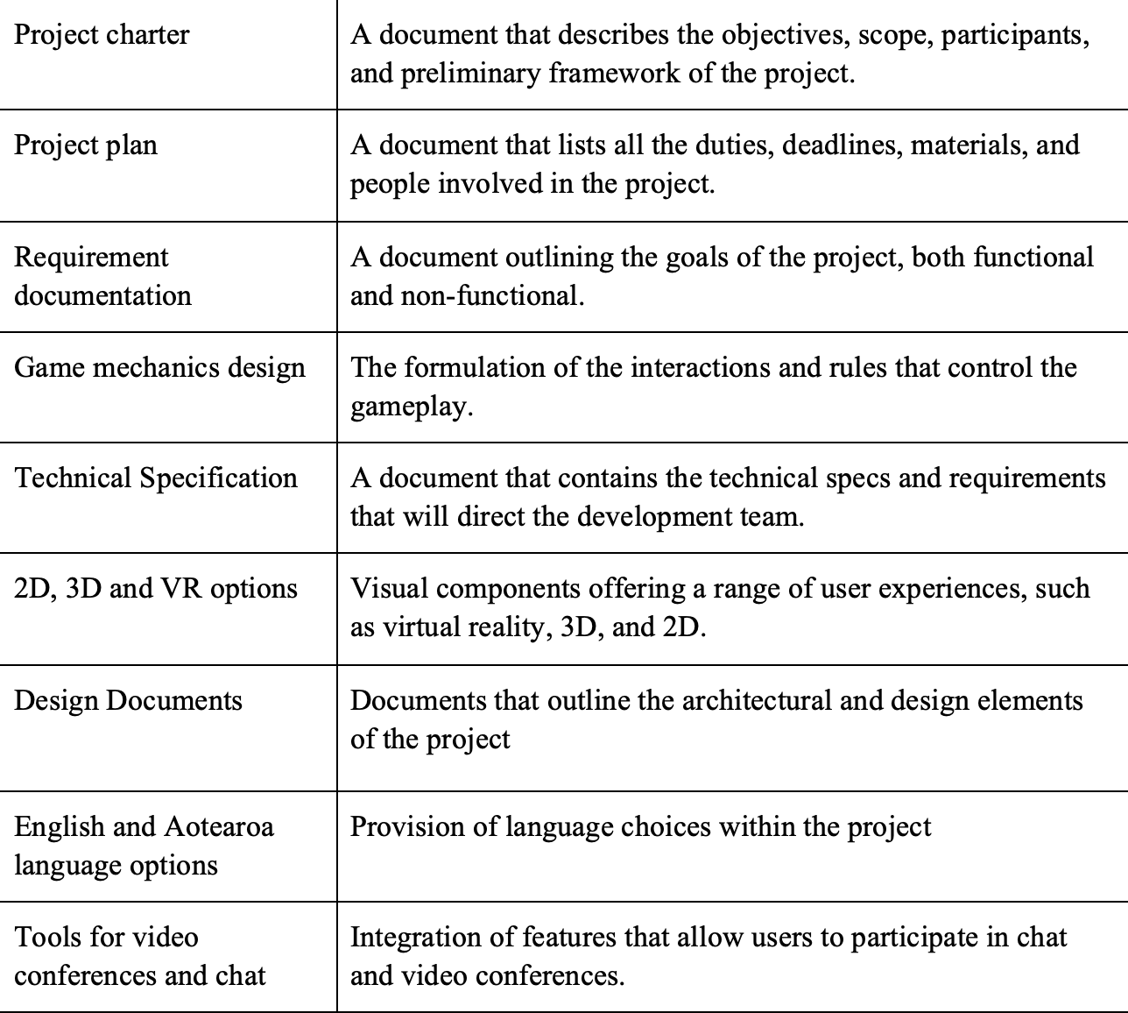
Figure 3Tangible deliverables

Intangible deliverables 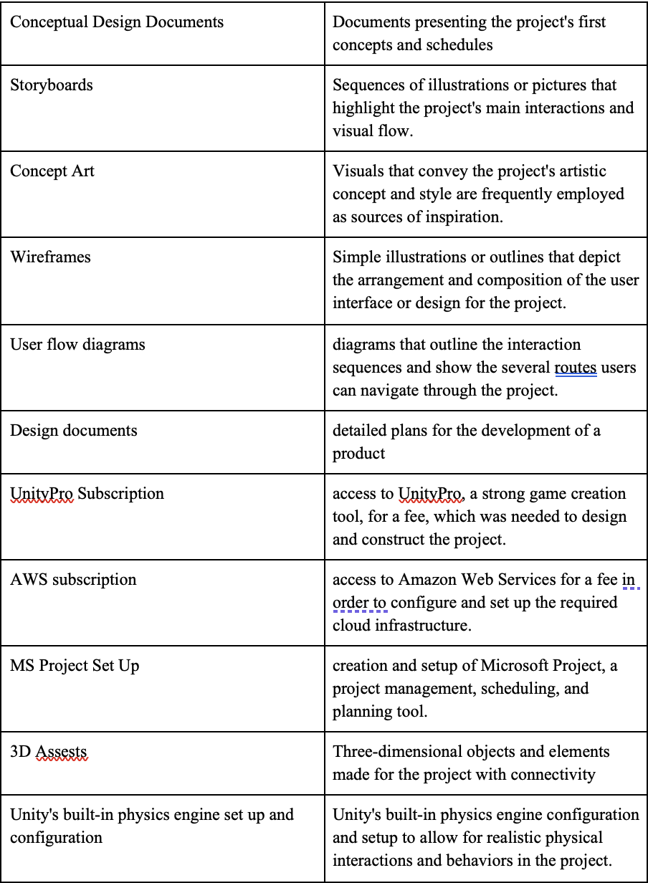
Figure 4. Intangible deliverables

3.3. Milestones

Milestones are essential markers in project management that indicate the conclusion of significant developments or the accomplishment of particular project goals (Bergner & Friedrich, 2010). According to Williams et al. (2015), milestones are frequently used to indicate the conclusion of project stages. They act as turning points in a project's timetable, signifying the end of one phase and the start of the next. Milestones are different from regular tasks or continuing activities in that they represent accomplishments that are crucial to the project's overall success and progress (Knutston, 1995). Below is the milestone of OPAIC IT project case.
The figure below are the milestones of the IT case study:
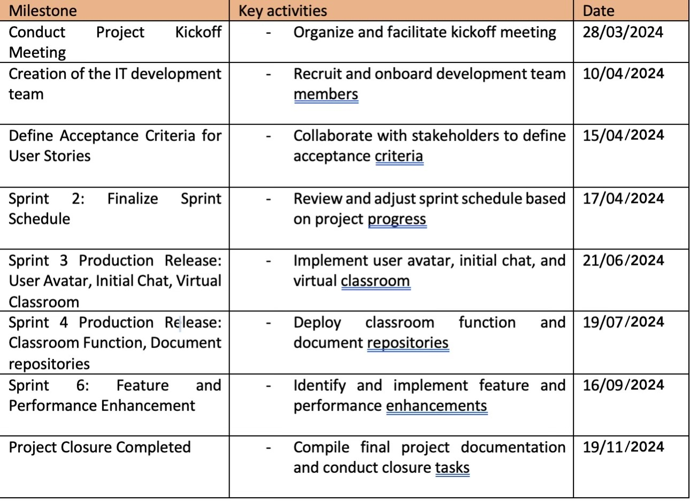
Figure 5. Project Milestone

3.4. Technical requirements

Requirements are essentially the standards or parameters that the project must adhere to in order to be recognized satisfactory and successful in resolving the stated issue (Kumar, 2003). They offer an ordered and comprehensible set of standards that direct the processes of creation and execution in the direction of the intended goals and results. There are two types of requirements: functional requirements and non-functional requirements (Becker et al., 2019. Below are more specified functional and non-functional requirements of the OPAIC IT case study.

3.4.1 Functional requirements

Functional requirements, also known as business requirements, are the particular features and capabilities that a stakeholder or client demands to be offered in a product (Becker et al., 2019). In the context of the OPAIC IT project, the functional requirements are outlined by the necessity of the online enhanced learning environment supporting simultaneous access by a single professor and the complete class. It is also anticipated that the system will have the capacity to support at least four distinct classes simultaneously. This requirement emphasises how important it is to be expandable and use resources effectively to guarantee smooth participation throughout several semesters. Furthermore, the necessity of resilient architecture and flexible design to support bigger educational ecosystems is emphasised because of the system's possible development into a licensed version for other tertiary providers.
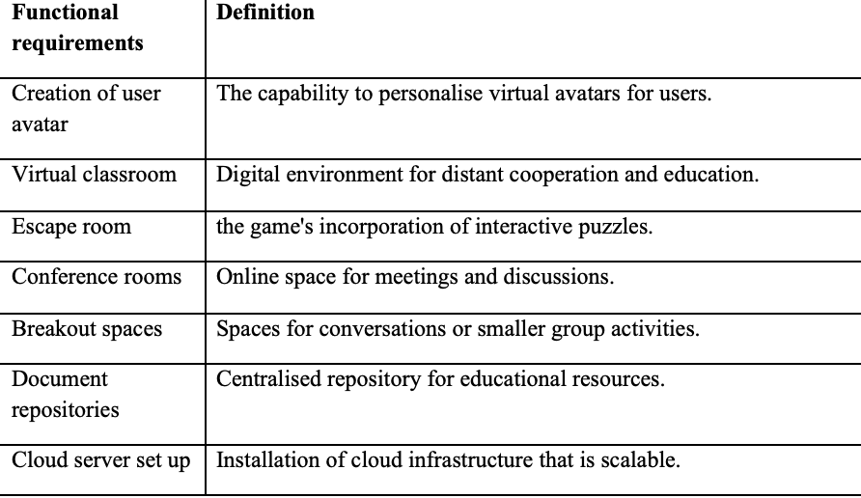
Figure 6. Functional requirements

3.4.1 Non-functional requirement

Non-functional needs are essential components that enhance a product's overall performance and effectiveness, even when they aren't explicitly requested by consumers (Eckhardt et al., 2016). In contrast to functional requirements, which highlight certain features and capabilities, non-functional requirements highlight the qualities that specify how the product functions. The development process must take these non-functional elements into account in order to produce a high-quality, well-rounded product that not only satisfies functional requirements but also operates safely and reliably in a variety of operational scenarios.
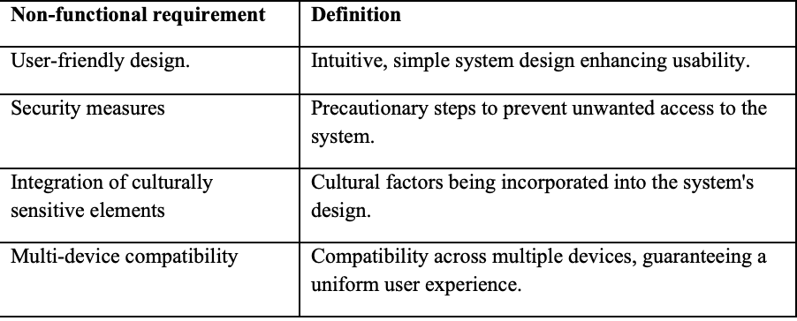
Figure 7. Non-functional requirement

3.5. Project Exclusions
Functional exclusion is the deliberate decision to leave out some components from the project scope (Sian, 2006). It is essential to specify any exclusions as soon as possible when defining the project scope. Komal et al. (2020) stated that when the scope of a project is unclear, miscommunications may arise, which may cause requirements to be misunderstood and possibly result in scope creep. Similarly, Sian (2006) demonstrated that exclusions specify exactly what falls beyond the project's bounds or what needs to be stated out of the project charter's scope.
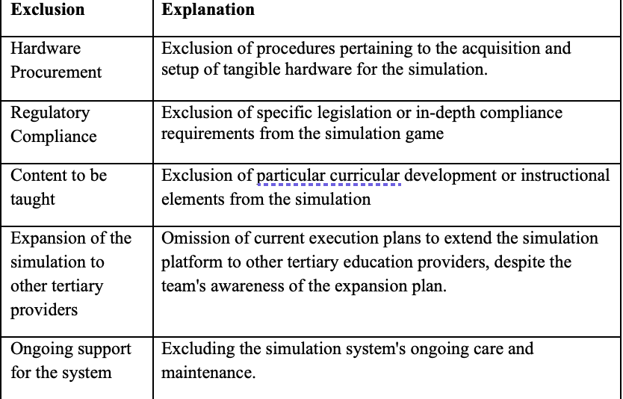
Figure 8. Project exclusion

3.6. Project Limitations

According to Sage et al. (2014), limitation refers to the definition of restrictions or limits that encircle a project's resources, scope, or time frame. Knowing limitations helps in setting realistic expectations, managing risks effectively, and ensuring project success overall. When it comes to the simulation game, understanding limitations directs the development process, making sure that resources are allocated effectively and that the project remains feasible within the specified constraints.
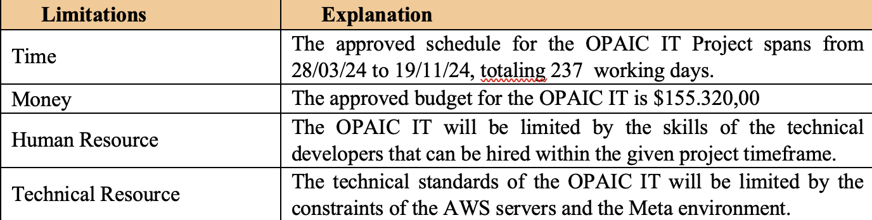
Figure 9. Project Limitation

4. Project Assumptions
Assumptions are specific beliefs or factors that are considered true for planning reasons even in the absence of evidence or a clear demonstration (Chapman, 2006). It's significant to note that assumptions are made when organising the project. Chapman (2006) also stated that without these presumptions, planning cannot begin, and inaccurate presumptions will lead to plans that are invalid.
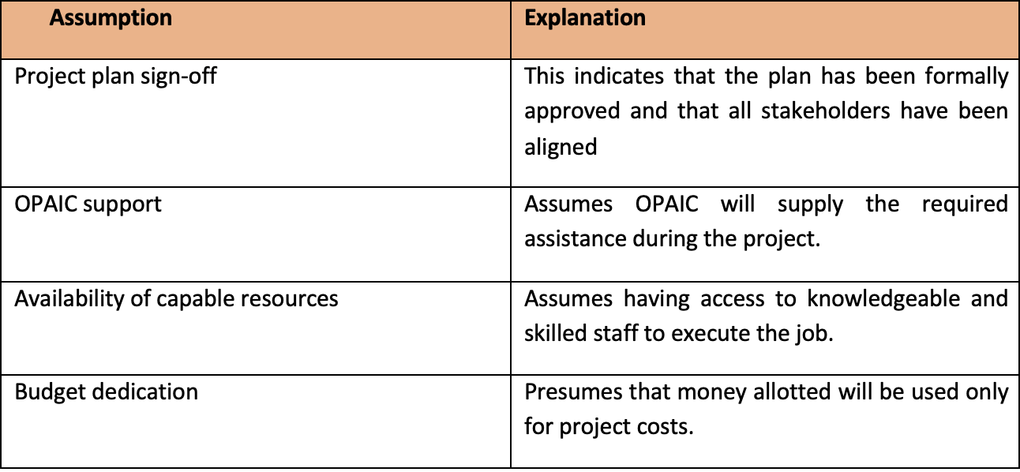
Figure 10. Project Assumption

5. Methodology

Because of its inherent rigidity and linear development, the Waterfall technique would be considered inappropriate for the OPAIC IT project. This would provide difficulties in integrating dynamic innovations and changing project needs (Gaborov et al., 2021). In contrast, the agile methodology provides a more collaborative and iterative approach that is better equipped to handle the project's dynamic nature and promotes innovation and continual improvement throughout the development process (Ozkan & Kucuk, 2016). Scrum's flexibility is demonstrated by its capacity to adjust to each project's particular needs and its ability to accept modifications to the product backlog even in the middle of a project (Rising & Janoff, 2000). The primary goal of scrum is to continuously release small, transparent functioning features while employing a variety of touchpoints to facilitate frequent feedback and cooperative decision-making (Baxter & Turner, 2023).

5.1 Justification

Thanks to its incremental and iterative methodology, SCRUM is flexible to adjust to changing needs and input, which is ideal for the OPAIC IT project. SCRUM would be used in the OPAIC IT project by dividing it into smaller units called sprints, which would normally last from one to four weeks (Baxter & Turner, 2023). Based on the project backlog, the team decides together during sprint planning which tasks to accomplish during the sprint (Rising & Janoff, 2000). Daily stand-up meetings give team members a transparent and aligned platform to discuss difficulties and progress and organise their work for the day. Furthermore, sprint retrospectives foster transparency and continuous improvement throughout the project lifecycle by enabling the team to evaluate current procedures and identify areas for development (Gaborov et al., 2021).
Transparency has become embedded in SCRUM methods, guaranteeing that all stakeholders are aware of the status, obstacles, and priorities of the project, which serve the requirement of the OPAIC IT project. SCRUM would be implemented in the OPAIC IT project by creating regular rituals and transparent channels of communication (Leong et al., 2023). Sprint planning sessions promote decision-making transparency by involving stakeholders in the prioritisation of tasks and the establishment of goals for the next sprint. At the end of every iteration, sprint reviews offer a chance to present finished work to stakeholders, get input from the user, and make sure it's in line with project goals.
SCRUM is especially well-suited for the OPAIC IT project because of its cross-functional and iterative methodology, which fosters collaboration. In this situation, SCRUM would promote cooperation by encouraging a shared sense of accountability and teamwork among team members (Ozkan & Kucuk, 2016) . Regular stand-up meetings would promote open discussion and teamwork, enabling participants to plan tasks, exchange ideas, and work through obstacles as a group.
SCRUM is ideally suited for the OPAIC IT project since it gives the team more control and accountability over their work. SCRUM would be used in this situation by forming cross-functional teams that are able to work independently and produce meaningful project increments (Rising & Janoff, 2000). With little intervention from outside sources, these teams could figure out how to accomplish their sprint objectives. Teams would have the authority to decide during the sprint and modify their strategy as necessary to produce excellent outcomes.

5.2 Maori Value: how you can apply Maori values

Adopting Māori ideals like Manaakitanga, Auahatanga, and Whanaungatanga should be implemented in the OPAIC IT project in several ways. For Manaakitanga, by actively encouraging open communication, empathy, and inclusivity, the project team can ensure that every member feels valued and accepted. This may include planning frequent team-building exercises and encouraging a spirit of belonging among team members. Auahatanga can also be embraced by fostering an innovative and creative culture that allows team members to experiment with novel tools and methods. This could include setting aside time for innovation workshops, hackathons, or brainstorming sessions to create fresh concepts and answers.

6. Project Risks and Risk Management Plan

PMI defines project risk as an unpredictable occurrence or consequence that, should it occur, will affect the project's goal (Ward & Chapman, 2003). The risk register, which keeps track of every possible risk and its associated probability, impact, owner, priority, and mitigation procedures, is where risks are normally registered (Chapman, 2006). Because risks are identified early on and preparations are in place to address issues when they happen, this offers the project manager greater confidence in carrying out the project (Ayala-Cruz, 2016).
For the OPAIC IT project, the following risks have been identified:
1. Testing delays: OPAIC teachers and students are required to complete testing in addition to their regular duties, and there may be delays because of these primary tasks.
2. Technical complexity: Development on Meta can be difficult because it is still a young technology and platform. Since they won't have much experience in this field, developers will need to construct intricate algorithms in order to develop the modules.
3. Imprecise requirements: If the user stories are not clear, there may be a need for revisions, which could cause major development delays.
4. Staff issues: It would be challenging to find technical resources to fill the development team's vacancies, given New Zealand's present labour shortage.
5. Scope creep: Considering the early phases of the project and the Scrum technique selected for implementation, the original set of deliverables may still alter. Modifications in scope may have an effect on costs and time.
Project Risk | Probability | Impact | Risk Register | Member Responsible | Mitigation
Testing delays | 1 | 3 | 3 | Project management | - Stakeholder roles and responsibilities are aligned at project launch.  - Making sure that communication plans are current in order to match testing schedules with current conditions.
Technical complexity | 3 | 3 | 9 | Technical Lead | • Confirm that a comprehensive technical assessment is completed  • Confirm that the technical resources employed possess the necessary technical
Imprecise requirements | 2 | 4 | 8 | Product Owner | • During the requirements gathering phase, clearly eliciting requirements from stakeholders.  • Including stakeholders in sprint reviews and demos to get continuous input.
Staff issues | 2 | 3 | 6 | Project Manager | • Examine possibilities for hiring a third party to handle development tasks.
Scope creep | 4 | 4 | 16 | Scrum Master | • During sprint reviews, regularly assess the project backlog to determine the current state and items still on the backlog.  • Managing prospective changes by applying the change management procedure.

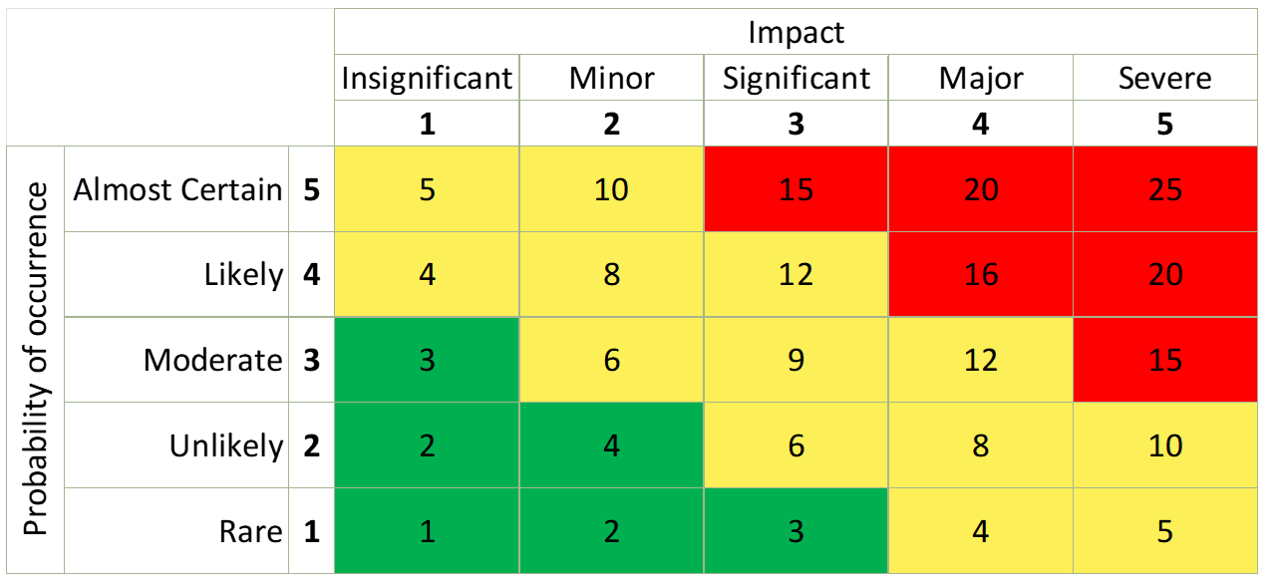
Figure 11. Risk Measurement

7. Project Organisation
For the OPAIC IT project, using a matrix structure might be the best course of action. Developing an online improved learning environment is one of the project's goals, and a matrix organisation enables a dual focus on needs and functional/technical requirements (Saunila et al., 2014). Furthermore, a balanced matrix structure can help optimise resource utilisation and guarantee successful coordination between functional and project teams (Hobday, 2000). In this structure, the power of project managers is balanced with that of line managers. Due to the intricate nature of the project and the requirement for cooperation among diverse departments, a matrix structure provides the adaptability for managing many project components while capitalising on pre-existing functional knowledge inside the business (Hobday, 2000).

Name | Functional role | Responsibilities | Reporting To
Irfaan | Project Manager | • Project management from start to finish.  • Control of scope, schedule, and costs.  •Supervise prompt correspondence with other stakeholders and the project sponsor.  • Controls risks and establishes mitigation plans in place. | Project sponsor
Kelcee | Scrum Master | • Manages the scrum rituals.  • Assures efficient team coordination and workflow management.  • Eliminates obstacles for the scrum teams. | Project Management
Timba | Product Owner | • Speaks on behalf of the client and is in charge of defining the requirements for the project.  • In charge of creating and prioritising the product backlog. | Project Management
Chung Nguyen | Technical Lead | • In charge of facilitating collaboration between the project manager's business resources and the development teams. | Project Management
Ly Pham | UI/UX Designer | • Develop user interface for the learning platform  • Assist developers in making sure the designs are correct | Technical Lead
Team A: Thang Nguyen  Team B: Thai Nguyen | Senior Developer (2) | • Create and design the software deliverables that are given to every team.  • Create new features and update the code with problem fixes.  • Take part in the code reviews.  • Serve as a coach and mentor to junior | Technical Lead
Team A: Alzara, Bobbi  Team B: Heidi, Nelia | Junior (2) | Assist senior developers with the software's design and development. | Senior Developer

8. Communications with Stakeholders
To handle the stakeholders effectively, different strategies might be required, depending on their degree of interest and impact. High-power and high-interest stakeholders, such as the Iwi consultant, the advisory board, and the project sponsor, need to be properly handled. It will be necessary to notify high-interest but low-power stakeholders (such as the OPAIC IT Team and testers) about the project's progress and any duties they might have to complete. Low-interest but powerful stakeholders such as OPAIC Finance Resource, must be satisfied because they have little financial investment in the project but may be necessary for its success. Finally, the low-interest and low-power stakeholders—OPAIC teachers and students—will need to be closely monitored because they will not significantly affect the project.

8.1 Stakeholders identification
Stakeholder | Role | Influence Level | Decisional Influence | Internal/External
Project Sponsor | OPAIC executive who will take on the role of learning platform owner | 5 | 5 | External
Advisory Board | Directors and significant OPAIC stakeholders who directly benefit from the project's completion | 4 | 4 | Internal
Iwi Consultant | Maori consultant from the iwi for continuing advice on the incorporation of suitable Maori practices | 4 | 4 | External
OPAIC Finance Resource | The OPAIC finance resource is in charge of allocating the project's budget. | 4 | 4 | Internal
OPAIC Teachers and Students | After the Arahi platform is put into production, OPAIC professors and students will use it. | 2 | 2 | Internal
OPAIC IT Team | OP's IT team will be in charge of continuing to support the system after it is put into production. | 3 | 3 | Internal
OPAIC Testers | End-user testing of the system is the responsibility of instructors and students for crucial integration points. | 3 | 3 | Internal

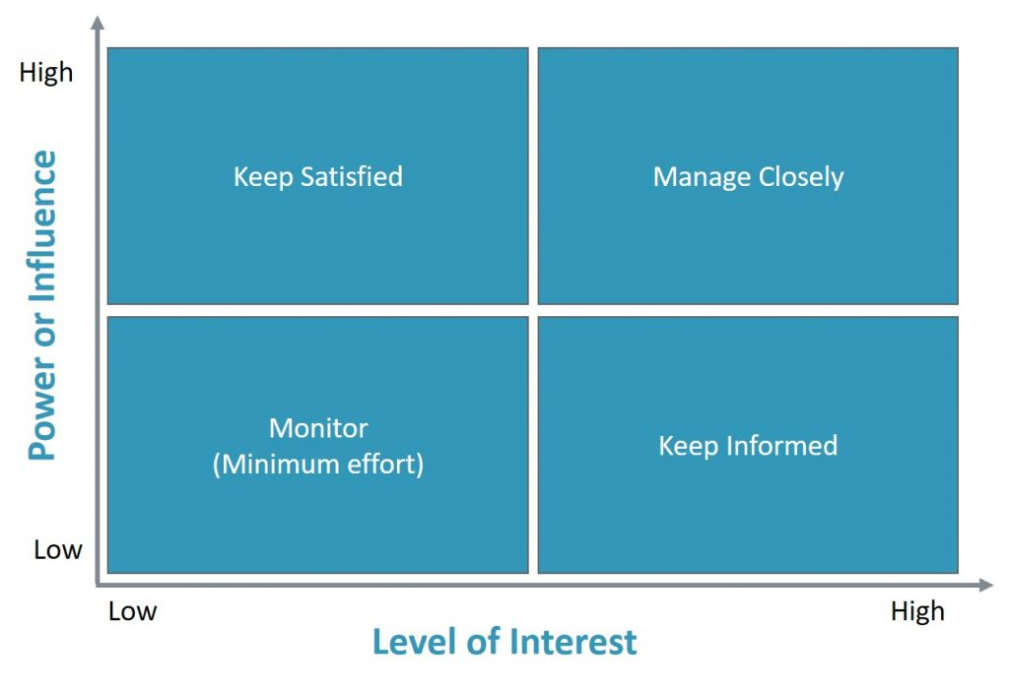
Figure 12. Level of interest

8.2 Stakeholder Communications Management Plan
The process of communications planning involves determining the many kinds of information required by each project stakeholder, including who needs what specific details, when, how often, and through which channels (Scholes & James, 1998). Depending on what the stakeholders require, these interactions can be emails, calls, or in-person meetings.

Role | Purpose | Mode/Chanel of Communication | Frequency | Participants
Project Kick-off | - Official kick-off of the project  - Aligning project goals and roles of each team members | face to face,  OPAIC room 700 | Thu 28/03/24 | All Stakeholders and Team Member
Milestone Status Report | Mile stone delivery | Email | Every Mondays, 10 AM | Project Sponsor, Product Owner, Project Team
Sprint Planning | Plan and prioritize tasks for the upcoming sprint, based on the project backlog. | Email | Fortnightly, Monday of a Second week in the month. 9 – 9:30 AM | Project Sponsor, Steering Committee, Product Owner, Project Team
Scrum Meetings | Facilitate daily stand-up meetings to discuss progress, address blockers, and align team members. | face to face,  OPAIC room 700 | Every day, 10 – 10:15 AM | Product Owner, Project Team
Project Demo | Showcase completed deliverables from the current sprint and gather feedback from stakeholders. | face to face,  OPAIC room 700 | At the end of every sprint, 2 hours each | Project Sponsor, Steering Committee, Product Owner, Project Team
Sprint Retrospective | Reflect on the previous sprint, identify areas for improvement, and implement changes to enhance future sprints. | face to face,  OPAIC room 700 | Fortnightly, Monday of a Second week in the month. 10 – 11 AM | Product Owner, Project Team
Risk Reviews  Change | Evaluate identified project risks, update risk priorities, and implement mitigation strategies. | Email | Quarterly, or as needed | Project Sponsor, Steering Committee, Project Manager, Change Requestor, Project Team
Advisory  Communications | Finalize decisions regarding submitted change requests and their impact on the project. | MS Teams call | As need | Project Sponsor, Steering Committee, Product Owner, Solutions Architect
Project Closure | Officially close out the project, including sign-off from stakeholders and handover of the final product. | face to face,  OPAIC room 700 | When project is completed and closed | Project Sponsor, Steering Committee, Product Owner, Project Team

9. Change management plan
Since every change has the potential to affect timelines, budgets, and scope, change management skills are critical to project management. A documented change request procedure that includes appropriate evaluations, approvals, and communications must be followed for any possible modification to the initially aligned scope (By, 2005). If a request is made to modify the project scope, the following change management procedure must be adhered to: 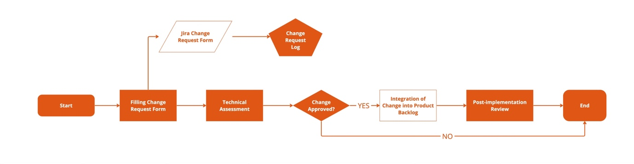
Figure 13. Change Management Flow
- To log a request, the requester must complete Jira's change request form (Atlassian, n.d.) The following details, which are specified in the change request template, must be on the form of:
- Requestor/owner of change
- Change description
- Affected deliverables or deliverables
- Change justification
- Type
- Risk modification
- Technical specifications
- Hazards
- Estimate of resources and costs
- Impact on quality
- The solution architect will evaluate the change to verify the complexity and recommended course of action.
- To approve necessary changes, a Change Advisory Board (CAB) made up of the Project Manager, Product Owner, Solutions Architect, and Project Sponsor will be established. The corresponding approvers' signoffs will be necessary, depending on the change's impact and nature.
- After the modification is accepted, it will be added to the product backlog.
- To evaluate the implementation results, a Post-implementation CAB review will be conducted for every implemented modification.

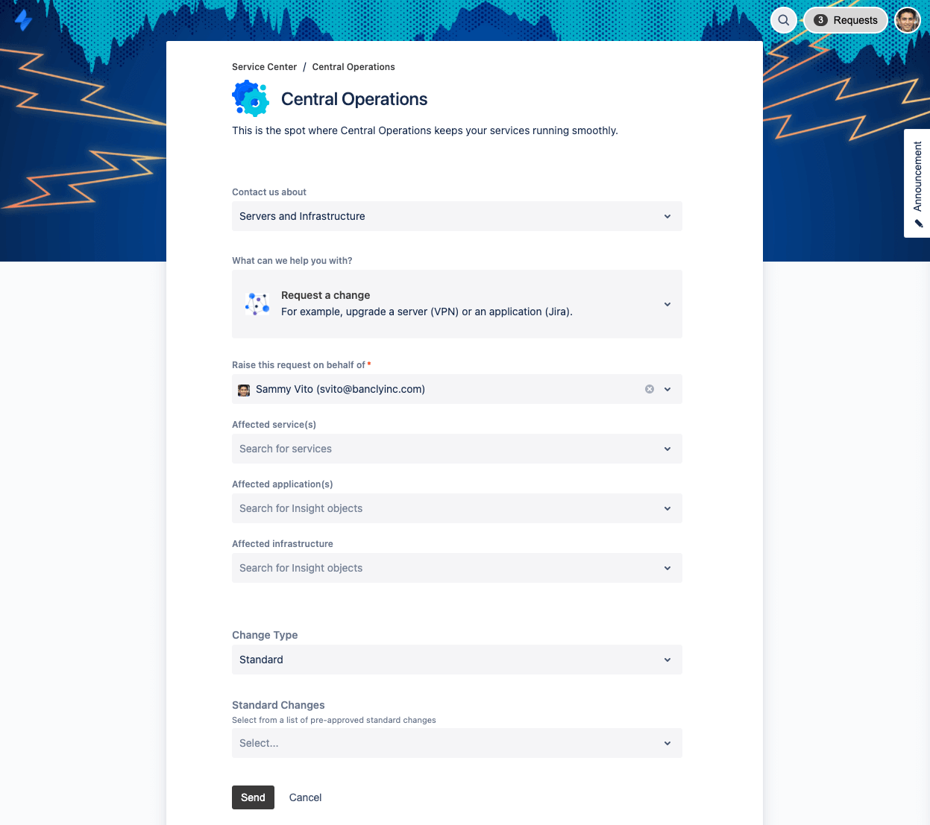
Figure 14. Jira Change Request Form

10. Project estimation technique
Project estimation gives the project team and stakeholders a rough notion of the amount of time and resources that will be required to finish a project, including estimates for both budget and schedule. There are various methods to estimate a project: top-down, bottom-up, parametric, analogous, and three-point estimates (Goodrich, 2014). In order to ensure accuracy, Bondale (2018) suggests using a minimum of two estimating techniques as a sanity check before submitting estimates to the project sponsor.
Here is a summary of some estimating methods:
- Analogous: Usually used to estimate the length of time or cost of a current project based on a comparable project that was completed in the past (of the same magnitude and type) (Shepperd & Schofield, 1997). It is crucial to remember that because every project is unique and can have variations in cost owing to inflation over time, the strategy is usually not as precise as other approaches.
- Parametric estimation, relatively similar to analogous estimation bases its estimate on a comparable past project; however, it takes scale discrepancies into account and modifies the estimate as necessary (Kwak & Watson, 2005)
- PERT (Program Evaluation and Review methodology) is another name for the three-point estimate methodology, which is a mathematical method based on the weighted average of three estimates of the job (optimistic, most likely, and pessimistic) (Atin & Afrianto, 2023)
- The top-down strategy involves estimating and gradually breaking down larger or more complex feature segments into smaller task packages as additional information becomes available (Hutchison-Krupat & Kavadias, 2015)
- Bottom-up approach: project estimates are generated by aggregating work package estimates, which are the lowest work tasks accessible to the project level (Hutchison-Krupat & Kavadias, 2015).
Because of its accuracy and scalability, a bottom-up method combined with parametric estimating approaches was chosen to implement for the OPAIC IT project. Both approaches support incremental elaboration, enabling iterative improvement as details of the project become apparent (Hutchison-Krupat & Kavadias, 2015). The bottom-up method is excellent at producing detailed estimates for complex activities, whereas parametric estimating adds depth by modifying past data for the total project scope.

11. Budget
According to PMI, cost management is the process of planning, estimating, budgeting, and controlling expenses to guarantee that the project is completed within the allocated budget (Brannan, 2006). These expenses fall into several categories, including labour and resource costs for humans.
Every expense mentioned in the plan for OPAIC IT project will be monitored in relation to OPAIC's capital expenditure statement. To secure the necessary resources, the project manager will work with the IT and procurement departments of OP.
The project's material and human resource requirements are broken down in the table below, along with the associated financial needs. This breakdown can also be found in the project's matching Microsoft Project file. Project Ārahi will cost $165.044 in total.

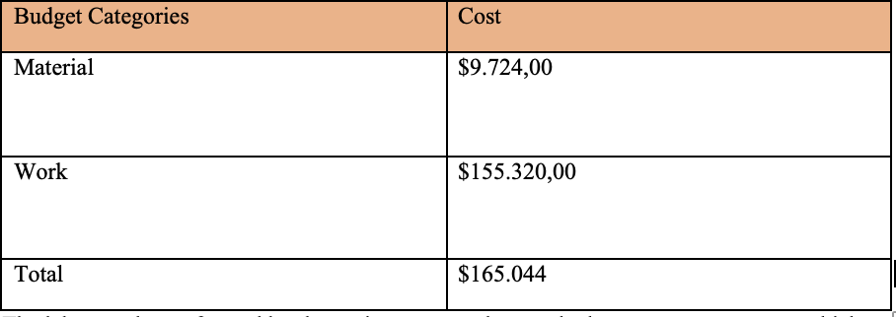
Figure 15. Project Budget
The labour to be performed by the project team makes up the human resources cost, which comes to $155.320,00
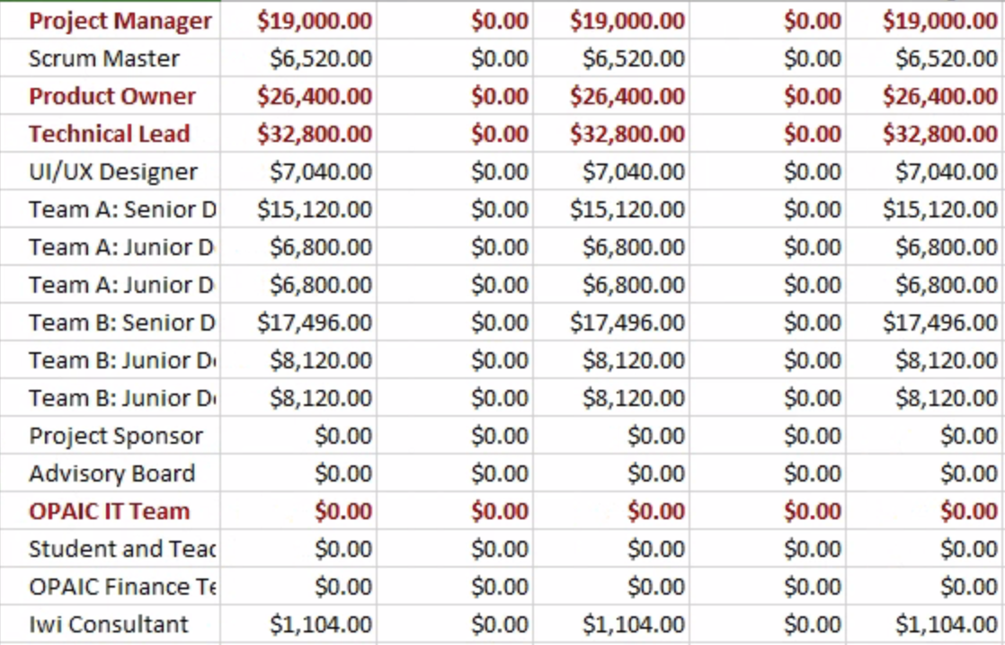
Figure 16. Project Labour Cost
The total cost of the materials is $15,910.66. The Appendix contains the price sources for the subscriptions as well as the accompanying USD to NZD conversion.
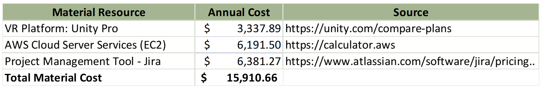
Figure 17. Project Material Cost

12. Quality Control and Audit
The aligned quality level decided upon during the project scope definition is known as project quality management. According to Brennan (2006), this covers all of the development team's efforts that determine whether the project will meet the goals for which it was launched. It is imperative to acknowledge that while contemplating quality control for a project, multiple tiers of quality standards must be considered.
The quality controls of the OPAIC IT team would be: 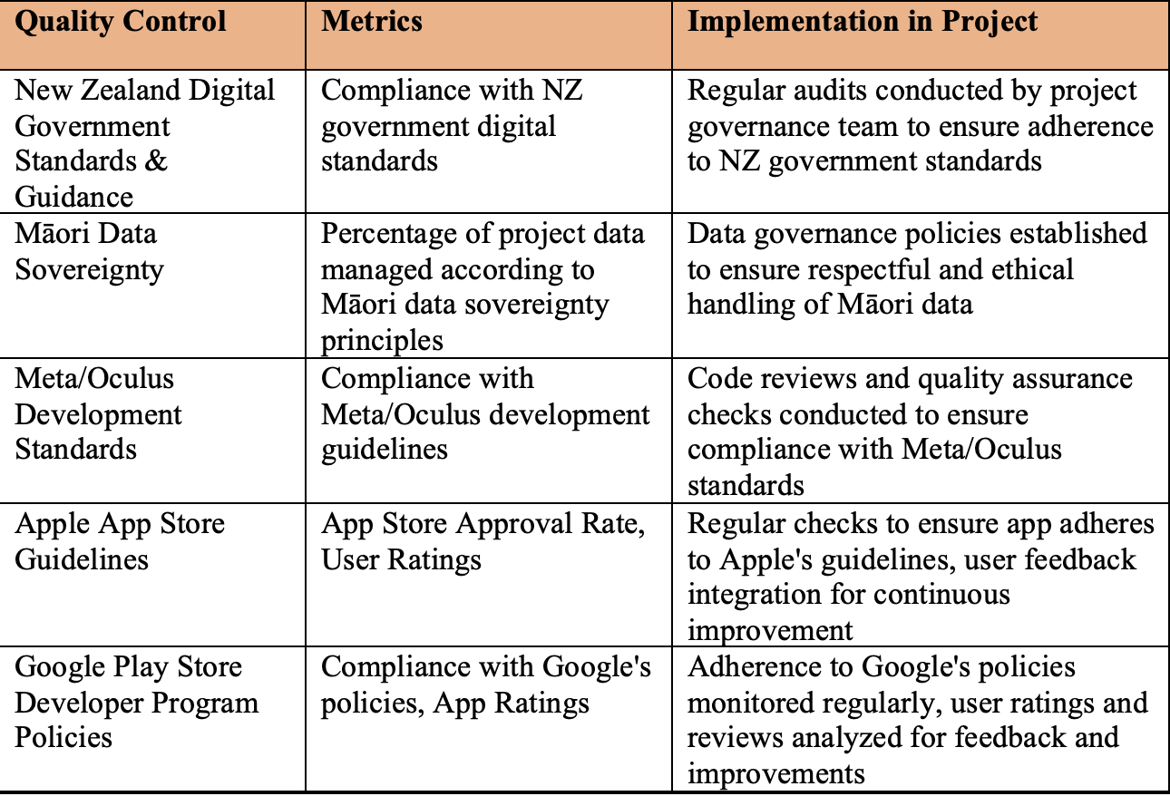
Figure 18. Project's quality control methods

13. Project Closure
The coordinated collection of tasks and deliverables needed to formally conclude a project is called the project closing (Czari & Jarander, 2015).
To formally conclude the OPAIC IT project, the following conditions must be achieved:
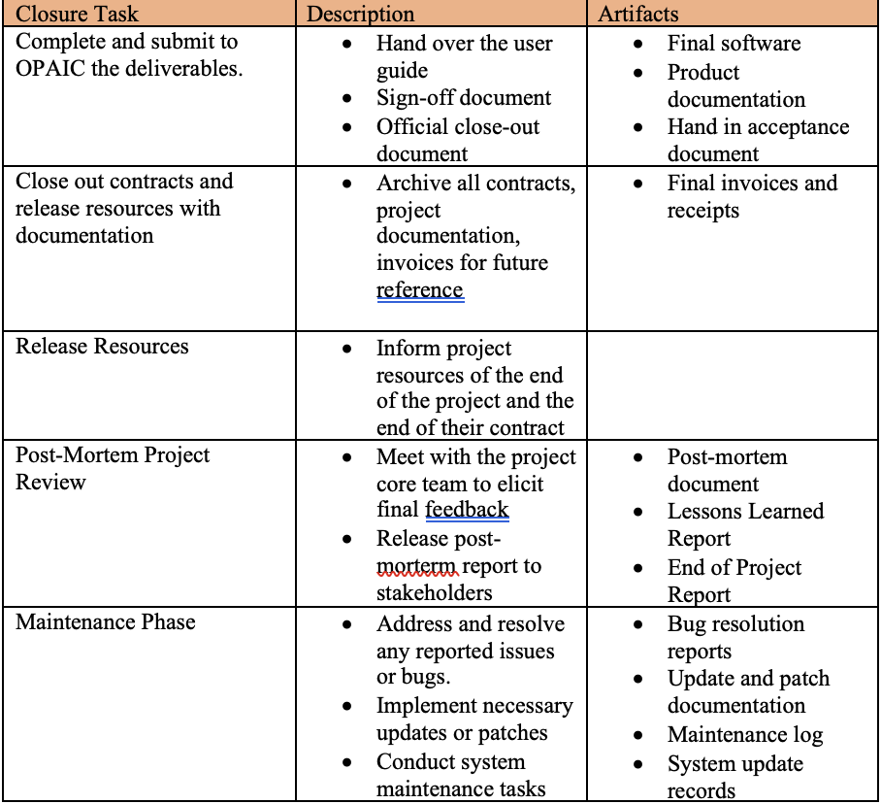
Figure 19. Project closure

References
Abdilahi, S., Fakunle, F., & Fashina, A. (2020). Exploring the extent to which project scope management processes influence the implementation of telecommunication projects. IX, 1–17.
Allee, V. (2008). Value network analysis and value conversion of tangible and intangible assets. Journal of Intellectual Capital, 9(1), 5–24. https://doi.org/10.1108/14691930810845777
Atlassian. (n.d.). Learn about change management in Jira Service Management. https://www.atlassian.com/software/jira/service-management/product-guide/getting-started/change-management#how-it-works
Ayala-Cruz, J. (2016). Project risk planning in high-tech new product development. Academia Revista Latinoamericana de Administración, 29(2), 110–124. https://doi.org/10.1108/ARLA-11-2015-0297
Baxter, D., & Turner, N. (2023). Why Scrum works in new product development: The role of social capital in managing complexity. Production Planning & Control, 34(13), 1248–1260. https://doi.org/10.1080/09537287.2021.1997291
Becker, P., Tebes, G., Peppino, D., & Olsina Santos, L. A. (2019). Applying an Improving Strategy that embeds Functional and Non-Functional Requirements Concepts. Journal of Computer Science & Technology, 19, no. 2. http://sedici.unlp.edu.ar/handle/10915/87772
Bergner, K., & Friedrich, J. (2010). Using Project Procedure Diagrams for Milestone Planning. In J. Münch, Y. Yang, & W. Schäfer (Eds.), New Modeling Concepts for Today’s Software Processes (pp. 88–99). Springer. https://doi.org/10.1007/978-3-642-14347-2_9
Brannan, L. (2006, November 8). Project budgeting—Pm knowledge areas -credibility. PMI® Global Congress 2006—Latin America, Santiago, Chile. https://www.pmi.org/learning/library/project-budgeting-management-knowledge-areas-8132
By, R. T. (2005). Organisational change management: A critical review. Journal of Change Management, 5(4), 369–380. https://doi.org/10.1080/14697010500359250
Chapman, C. (2006). Key points of contention in framing assumptions for risk and uncertainty management. International Journal of Project Management, 24(4), 303–313. https://doi.org/10.1016/j.ijproman.2006.01.006
Czari, E., & Jarander, I. (2015). Closure in IT Projects—A Never-Ending Story. https://urn.kb.se/resolve?urn=urn:nbn:se:hb:diva-10451
Eckhardt, J., Vogelsang, A., & Fernández, D. M. (2016). Are ‘non-functional’ requirements really non-functional? An investigation of non-functional requirements in practice. Proceedings of the 38th International Conference on Software Engineering, 832–842. https://doi.org/10.1145/2884781.2884788
Gaborov, M., Karuović, D., Kavalić, M., Radosav, D., Milosavljev, D., Stanisaljev, S., & Bushati, J. (2021). Comparative analysis of agile and traditional methodologies in IT project management. Journal of Applied Technical and Educational Sciences, 11(4), 1–24. https://doi.org/10.24368/jates.v11İ4.279
Hobday, M. (2000). The project-based organisation: An ideal form for managing complex products and systems? Research Policy, 29(7), 871–893. https://doi.org/10.1016/S0048-7333(00)00110-4
Hutchison-Krupat, J., & Kavadias, S. (2015). Strategic Resource Allocation: Top-Down, Bottom-Up, and the Value of Strategic Buckets. Management Science, 61(2), 391–412. https://doi.org/10.1287/mnsc.2013.1861
Ika, L. A. (2009). Project success as a topic in project management journals. Project Management Journal, 40(4), 6–19. https://doi.org/10.1002/pmj.20137
Komal, B., Janjua, U. I., Anwar, F., Madni, T. M., Cheema, M. F., Malik, M. N., & Shahid, A. R. (2020). The Impact of Scope Creep on Project Success: An Empirical Investigation. IEEE Access, 8, 125755–125775. https://doi.org/10.1109/ACCESS.2020.3007098
Knutston, J. (1995, June). How to manage a milestone, or managing by deliverables. PM Network. https://www.pmi.org/learning/library/manage-milestone-managing-deliverables-10437
Kumar, V. S. (2003, September 25). Requirements management for improved project performance. Requirements Management, Business Analysis. PMI® Global Congress 2003, North America, Baltimore, MD. Newtown Square, PA. https://www.pmi.org/learning/library/requirement-improved-project-performance-7678
Leong, J., Yee, K. M., Baitsegi, O., Palanisamy, L., Ramasamy, R. K., & Link to external site, this link will open in a new tab. (2023). Hybrid Project Management between Traditional Software Development Lifecycle and Agile Based Product Development for Future Sustainability. Sustainability, 15(2), 1121. https://doi.org/10.3390/su15021121
Malsam, W. (2023, May 2). What Is a Project Deliverable? Definition, Examples & More. ProjectManager. https://www.projectmanager.com/blog/project-deliverable
Ozkan, N., & Kucuk, C. (2016). A Systematic Approach to Project Related Concepts of Scrum. Revista de Management Comparat International, 17(4), 320–334.
Rising, L., & Janoff, N. S. (2000). The Scrum software development process for small teams. IEEE Software, 17(4), 26–32. https://doi.org/10.1109/52.854065
Sage, D., Dainty, A., & Brookes, N. (2014). A critical argument in favor of theoretical pluralism: Project failure and the many and varied limitations of project management. International Journal of Project Management, 32(4), 544–555. https://doi.org/10.1016/j.ijproman.2013.08.005
Saunila, M., Mäkimattila, M., & Salminen, J. (2014). Matrix structure for supporting organisational innovation capability. International Journal of Business Innovation and Research, 8(1), 20–35. https://doi.org/10.1504/IJBIR.2014.058044
Scholes, E., & James, D. (1998). Planning stakeholder communication. Journal of Communication Management, 2(3), 277–285. https://doi.org/10.1108/eb023471
Sian, S. (2006). Inclusion, exclusion and control: The case of the Kenyan accounting professionalisation project. Accounting, Organizations and Society, 31(3), 295–322. https://doi.org/10.1016/j.aos.2005.01.004
Sokowski, D. (2015). Mastering Project Management Integration and Scope: A Framework for Strategizing and Defining Project Objectives and Deliverables. FT Press.
Turner, J. R., & Turner, J. R. (1999). The handbook of project-based management: Improving the process for achieving strategic objectives (2. ed). McGraw-Hill.
Ward, S., & Chapman, C. (2003). Transforming project risk management into project uncertainty management. International Journal of Project Management, 21(2), 97–105. https://doi.org/10.1016/S0263-7863(01)00080-1
Williams, P., Ashill, N. J., Naumann, E., & Jackson, E. (2015). Relationship quality and satisfaction: Customer-perceived success factors for on-time projects. International Journal of Project Management, 33(8), 1836–1850. https://doi.org/10.1016/j.ijproman.2015.07.009

Appendix
